CN ASSIGNMENT 5
Q1. Configure Static Route in Cisco packet tracer 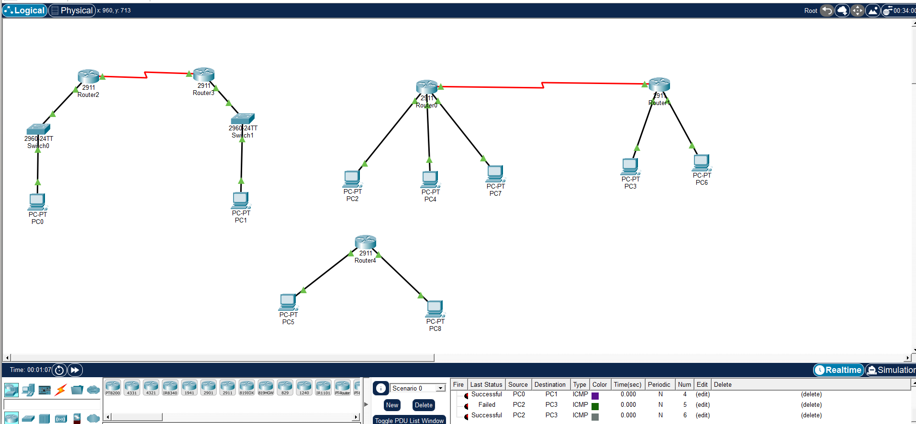
Commands for Router 1:
R1> enable
R1# configure terminal
R1(config)# interface gig 0/0/0
R1(config-if)# ip address 192.168.1.1 255.255.255.0
R1(config-if)# no shutdown
R1(config-if)# exit
R1(config)# interface gig 0/0/1
R1(config-if)# ip address 10.0.0.1 255.255.255.252
R1(config-if)# clock rate 64000
R1(config-if)# no shutdown
R1(config-if)# exit
Commands for Router 2:
R2> enable
R2# configure terminal
R2(config)# interface gig 0/0/0
R2(config-if)# ip address 10.0.0.2 255.255.255.252
R2(config-if)# no shutdown
R2(config-if)# exit
R2(config)# interface gig 0/0/1
R2(config-if)# ip address 172.16.0.1 255.255.0.0
R2(config-if)# no shutdown
R2(config-if)# exit
Verify interface configuration
show ip interface brief
Display routing table before static routing
show ip route
Configure static route on Router R1
R1(config)# ip route 172.16.0.0 255.255.0.0 10.0.0.2
Configure static route on Router R2
R2(config)# ip route 192.168.1.0 255.255.255.0 10.0.0.1

Q2. Suppose you want to create 3 subnets of a network having network address 198.168.1.0. In another network with network address 220.168.2.0, you want to create 2 subnets. For this scenario configure the end devices and routers accordingly. Connect two different networks (both are subnetted) through static routing and show the message transmission among hosts of the two networks.
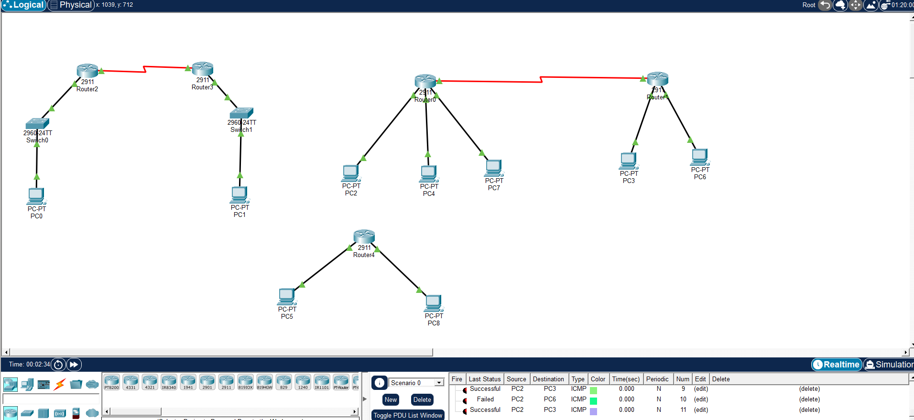
Commands for Router 1

enable
configure terminal
interface gig0/0/0
ip address 198.168.1.1 255.255.255.192
no shutdown
interface gig0/0/1
ip address 198.168.1.65 255.255.255.192
no shutdown
interface gig0/0/2
ip address 198.168.1.129 255.255.255.192
no shutdown
interface serial0/0/0
ip address 10.0.0.1 255.255.255.252
clock rate 64000
no shutdown
exit

ip route 220.168.2.0 255.255.255.128 10.0.0.2
ip route 220.168.2.128 255.255.255.128 10.0.0.2
end
Commands for Router 2
enable
configure terminal
interface gig0/0/0
ip address 220.168.2.1 255.255.255.128
no shutdown
interface gig0/0/1
ip address 220.168.2.129 255.255.255.128
no shutdown
interface serial0/0/0
ip address 10.0.0.2 255.255.255.252
no shutdown
exit
ip route 198.168.1.0 255.255.255.192 10.0.0.1
ip route 198.168.1.64 255.255.255.192 10.0.0.1
ip route 198.168.1.128 255.255.255.192 10.0.0.1
end

Q3. Connect two networks having network address 192.168.3.0 and 224.152.1.0 respectively. Network 1 having 4 and network two having 3 hosts. Connect two different networks through a router. For this scenario configure the end devices and routers accordingly and show the message transmission among hosts of the two networks.
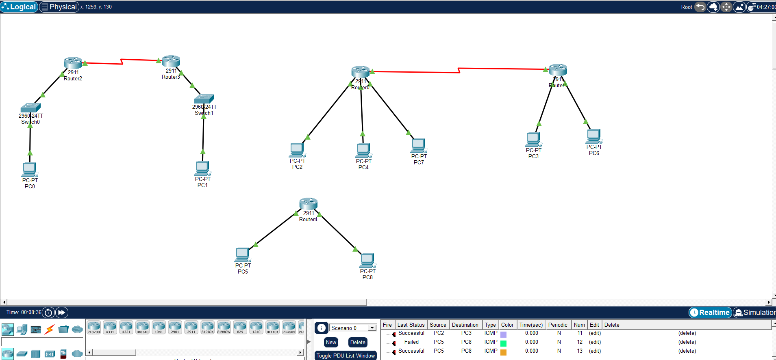
Command for Router 1
enable
configure terminal
interface gig0/0/0
ip address 192.168.3.1 255.255.255.248
no shutdown
interface gig0/0/1
ip address 224.152.1.1 255.255.255.248
no shutdown
end

